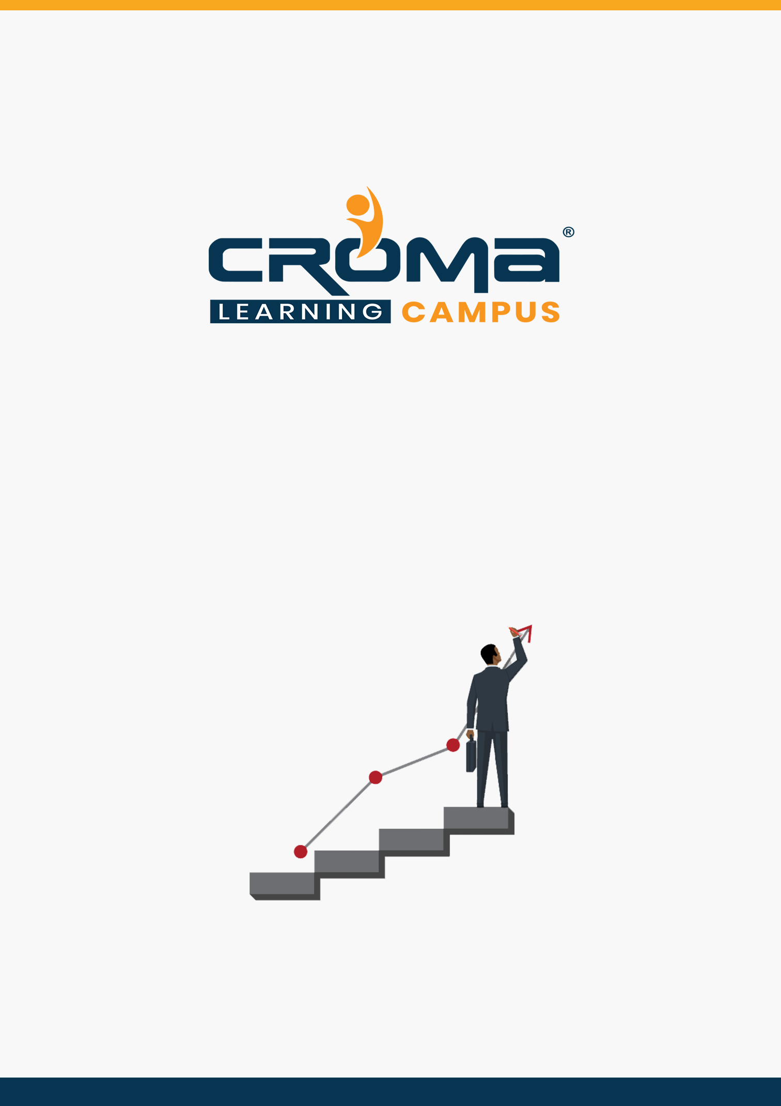

**Microsoft Dynamics CRM Functional Training Curriculum**

**STRUCTURE**

**www.cromacampus.com | helpdesk@cromacampus.com | +91-120-4155255**

**Microsoft Dynamics CRM Functional Training Curriculum**

“Our MD CRM functional training makes sure that you are way ahead of your colleagues. So, hurry up and enroll today to work smartly.”

**About Croma Campus:**

Croma Campus Training & Development Private Limited is an education platform since 2010 providing rigorous industry-relevant programs designed and delivered in collaboration with world-class faculty and industry.

* Hands-On Live Projects
* Simulation Test Papers
* Industry Cases Studies
* 61,640+ Satisfied Learners
* 140+ Training Courses
* 100% Certification Passing Rate
* Live Instructor Classroom / Online Training
* 100% Placement Assistance

**Course Objectives:**

* Use common functionality and implementation tools
* Configure security, processes, and options
* Manage Finance and Operations data
* Validate and support the solution
* Set up and configure financial management
* Implement and manage accounts payable and expenses
* Implement accounts receivable, credit, collections, and revenue recognition
* Manage budgeting and fixed assets.

**Course Description:**

Use this certification to prove your skills and help advance your career, if you have experience as a functional consultant who analyses business requirements and translates them into successful business processes and solutions based on industry best practices. You need to have experience in implementing and configuring Dynamics 365 Finance to meet business requirements.

This certification is a good fit for people in finance departments who work in accounts receivable, accounts payable, general ledger, fixed assets, budgeting, cost accounting and cost management, or expenses. You must have a fundamental understanding of business accounting principles and financial operations.

**Croma Campus Training Program Deliverables:**

* **Session Recordings** - Original Class Room Voice & Video Recording
* **Training Material** - Soft Copy Handbooks
* **Assignments** | Multiple Hands-on Exercises
* **Test Papers** - We provide **Practice Test** as part of our course to help you prepare for the actual certification exam.
* **Live Case Studies**
* **Live Projects** - Hands-on exercises and Project work. You will work on real time industry-oriented projects and assignments for each module to practice.
* **Key focus on Hands-on exercises and Project work**. You will work on real time industry-oriented projects.
* Faculty with more than **10+ Years of Experience** in the Industry.
* **Technical Resume Designing & Job Assistance:** With more than 100+ Clients across the Globe and we help learners to get a good job in their respective field. We also help learners with resume preparation.
* **Interview Q&A**
* **About Croma Campus Training Certificate:** Croma Campus will provide you with an industry-recognized (Certified by **ISO 9001:2015** & **E-Cell IIT Jodhpur**) course completion certificate which has lifelong validity.
* **How I Unlock my Croma Campus Certificate:** Attend Complete Batch & Submit at least One Completed Project.

**Course Content:**

**Module 1: Microsoft Dynamics CRM Overview**

* What is CRM?
* How to Access CRM?
* How to Activate 30 days CRM online trial version
* Difference between CRM Online and CRM on- premise Version
* Three Modules in CRM - Sales, Marketing and Services
* CRM Records:
  + Owner of the record
  + Status of the record
  + Sorting
  + Assigning and sharing Record
  + Views -System Views and Personal View
  + Editable Grid
* Search and Advanced find search
* MS Dynamics CRM Architecture
* Setting Personal Options

**Module 2: Customizing Entities and Forms**

* MS CRM Entity Model
* Customization Concepts – Entity Types and Attributes Data Type
* Creating Custom Entities, Attributes and main form and Global Option Set
* Form Customization Overview.
* Create and Modify Forms.
* Types of Forms in CRM -
  + Quick Create Form
  + Quick View Form
  + Mobile form
* Create and manage Multiple Main Form
* Role based Form

**Module 3: Managing Relationships**

* Types of Entity Relationships
* Relationship Behaviours
* Creating Entity Relationships

**Module 4: Solution Concepts**

* Default Solution
* Managed Solution
* Unmanaged Solution
* Managed Properties

**Module 5: Building a Security Model in Microsoft Dynamics CRM**

* Introduction to Business Unit
* Team
* User
* Security Model in CRM –
  + Role Based Security, Access rights and Privileges
  + Record Level Security
  + Field Level Security
* Auditing Overview

**Module 6: Introduction to Sales Management**

* Sales Life Cycle
* Convert Activity Records to Leads
* Qualifying and Disqualifying Leads
* Create Opportunities and Work with Opportunity Forms and records
* Adding Line Items (Opportunity Products) to Opportunities
* Quote Management
* Working with Order
* Working with Invoices
* Create, Maintain, and Use Sales Literature

**Module 7: Working with the Product Catalog**

* Unit Group and configure Unit
* Adding and Maintaining Products
* Price List and associate price list with Product
* Discount List
* Product Family,
* Product and Product Bundle configuration

**Module 8: Introduction to Marketing Management**

* Marketing Life Cycle:
* Campaign and Quick Campaign,
* Marketing list- Static and Dynamics Marketing list
* Campaign Activity
* Campaign Response

**Module 9: Introduction to Service Management**

* Overview of service module
* Service Management & Service Scheduling
* Case Entity
* Routing Rules
* Queue Management
* Private Queue & Public Queue
* Add case to a queue based on routing rule
* SLA (Service Level Agreements)
* Type OF SLA
* Standard SLA & Enhanced SLA
* Using business scenario to implement SLA
* Entitlement
* Create an entitlement: From Template & from scratch
* Define Entitlement Terms
* Associate entitlements to cases
* Using business scenario to implement Entitlement
* Using Service Level Agreement (SLA) with Entitlement
* Knowledge Base Article: (a) Directly create (b) Create from Template
* Creating Subject for knowledge-based Article

**Module 10: Reports**

* Running Built-in Reports
* Creating and updating Report in CRM
* Grouping, Sorting and Exporting Reports

**Module 11: View, Charts and Dashboard**

* View
* Personal View & System View
* Charts
* Personal Chart & System Chart
* Dashboard
* Personal Dashboard & System Dashboard

**Module 12: Email Functionality in Microsoft Dynamics CRM**

* Email Template
* Email Signature
* Configure Email

**Module 13: Configuring Business Rules in Microsoft Dynamics CRM**

* Configure Business Rules

**Module 14: Implementing Business Processes**

* Overview of Business Process Flow
* Creating Business Process Flow with condition
* Overview of Workflow
* Creating Workflows through Workflow Designer
* Overview of Dialogs
* Creating Dialog Pages, Prompt and Response
* Working with Input Parameters in Dialogs

**Module 15: Plugins**

* Overview of Plug-ins
* The Event Execution Pipeline
* Deploying Plugins
* Debugging Plugins

**Module 16: Application Event Programming**

* Client-side scripting using Java Script
* Working with I-Frames
* Working with Web Resources

**Module 17: Data management**

* Duplication Detection Settings and Rules
* Bulk Record Deletion
* Data Maps and Date Imports

**Module 18: Ribbon Customization**

* Creating & Hiding Ribbon Elements
* Enabling & Disabling Ribbon Elements
* Working with Site Maps

**Module 19: Filed Service**

* Overview of Field Service
* Work Order Life Cycle
* Work Order Creation
* Service Task Creation

**Module 11: Placement Guide**

* Tips to clear an Interview
* Common Interview questions and answers
* Microsoft Dynamics 365 Functional Interview Questions
* Resume Building Guide
* Career roadmap and certifications
* Attempt for the Global Certification Exam
* Start applying for Jobs